Application Instructions 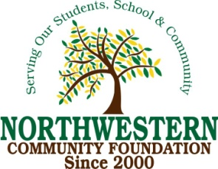

Please complete the application form for the Northwestern Community Foundation Continuing Education Scholarship and submit it by April 20th

Please mail or email the completed application to the address below:
Northwestern Area School
221 3rd Street
Mellette, SD 57461
Anthony.Redman@k12.sd.us

Requirements for the Northwestern Community Foundation Continuing Education Scholarship
• Must be a graduate of Northwestern High School
• Must be accepted or in the process of applying into a Master’s or Doctoral degree program, or enhancing a vocational degree by adding a second degree.

We look forward to receiving your application.

Sincerely,

Northwestern Community Foundation

Personal Information

First Name: Last Name:
Address: City: State: Zip:
Phone:
Email:

Educational Information
High School: GPA: ACT:
Date of graduation:

College/University: Location:
Degree Awarded:
Date of Graduation

Graduate/Advanced Degree Information
College/University: Location:
Degree Pursuing:
Expected Date of Graduation:

Work Experience (Please list locations and dates):

Extracurricular Activities/Clubs or Organizations
- ____________________________________________________________________
- _____________________________________________________________________
- _____________________________________________________________________
- _____________________________________________________________________

Essay
Respond to the statements below in essay form. Attach as a separate document.
(500 word maximum)
- Please tell us about any experiences that have influenced your decision to pursue
a graduate or advanced degree.
- Explain how graduating from Northwestern School may have impacted or prepared you for your post high school career/college journey.

